Restore Supabase

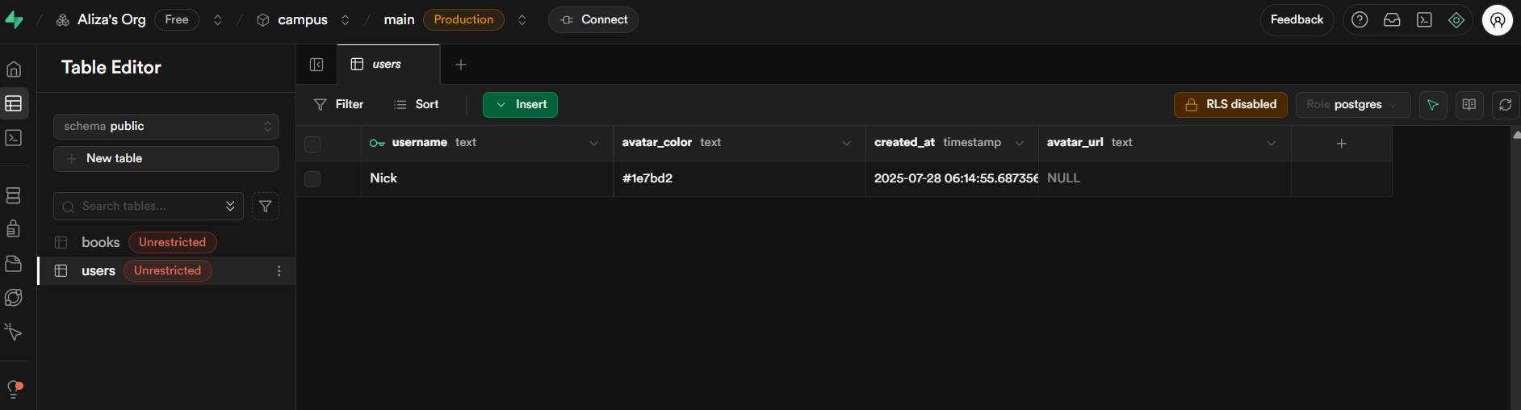

Start Chatserver

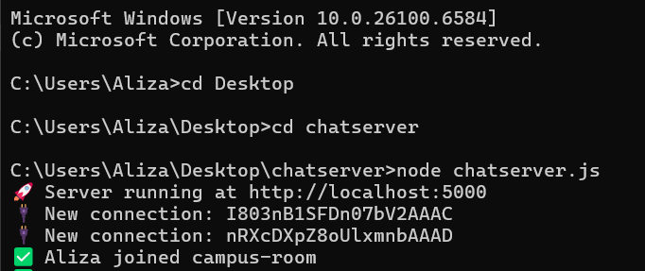

Run the app

